Category Summary
Path : Reports >> Category Summary.
Steps to reach Category Summary:
Step 1 : Reports in Steps to reach Category Summary : Open the Reports module from the Billing Application(POS).
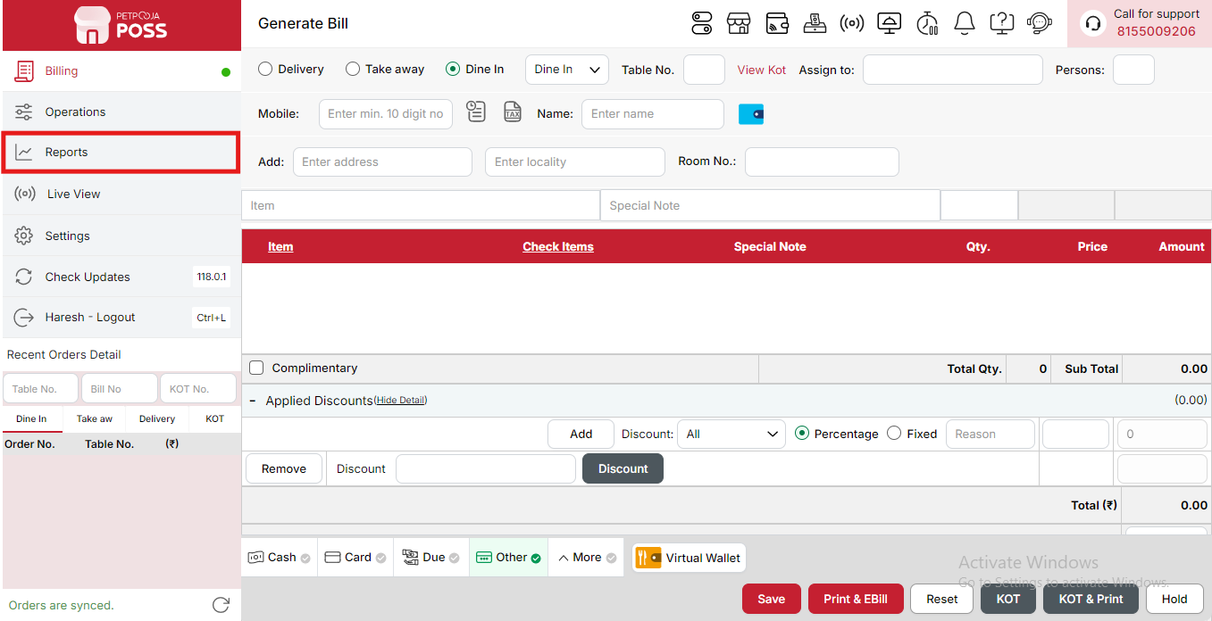
{Image Name: Reports Option,
Description: The red box highlights the “Reports” option in the sidebar menu. This section allows users to view and analyze various business reports, such as sales, billing, and order summaries, helping in effective tracking and decision-making.Here is an image of Step 1 Report in Steps to Reach Category Summary.}
Step 2 : Category Summary in Steps to reach Category Summary : Select Category Summary to view summarized sales and performance data for each item category.
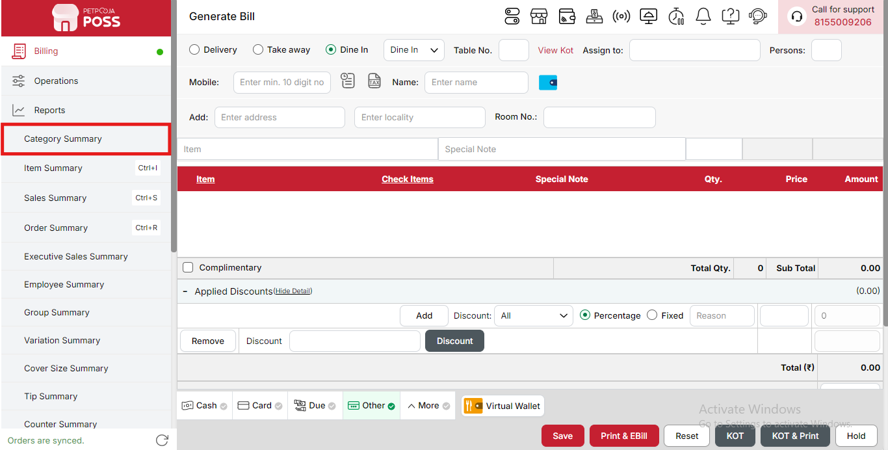
{Image Name: Category Summary,
Description: The red box highlights the “Category Summary” option under the Reports section. This feature provides a detailed breakdown of sales and performance by category, helping users analyze which types of items are selling best and track overall category-wise performance.Here is an image of Step 2 Category Summary in Steps to Reach Category Summary.}

Key features of Category Summary :
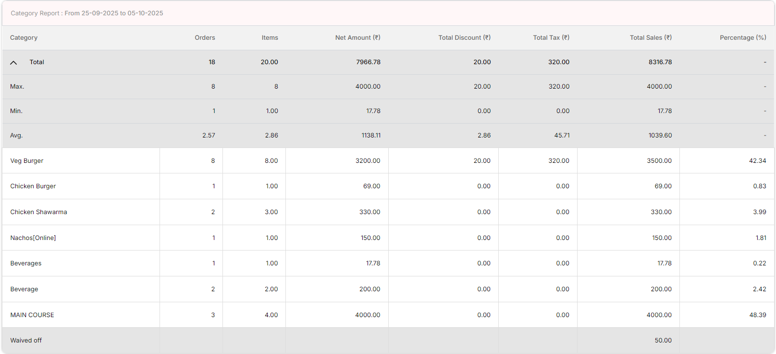
{Image Name: Category Report Overview,
Description: This image highlights in the red box the Category Summary section, where you can view your complete category report including details of sales, tax, and performance for each category.}
(Category Summary) Note: If you are not able to see or use the Category Summary option in your billing application reports, it means that you do not have the required permission. To enable this, you need to go to the Owner Dashboard and open the User Management section. Inside User Management, you will find a permission called Category Summary. You must checkmark this option to give access.
If you are not able to see reports for more days, you can enable the More Days permission. If you do not want any day restriction while viewing reports, you must set No Restriction in your User Management settings. After allowing the permission(s), perform a manual sync so the system updates the rights properly. Once the sync is done, log out from the billing application and then log in again. After this process, the Category Summary report option will become visible, and you will be able to see reports as per your configured day settings without any problem.

1. Category Report Duration (Category Summary) :
This shows the time period for which the report is created.
Example: From 01-09-2025 to 05-10-2025.
It helps to check sales and performance of each food item during this date range. You can change these dates to see reports for different time periods.

2. Category (Category Summary) :
This is the name of the item or product group. It shows which items were sold and helps to identify each product clearly.

3. Orders (Category Summary) :
This shows how many orders were placed for each item. It helps to know how many times each product was ordered.

4. Items (Category Summary) :
This shows how many total pieces or quantities were sold for each product. It helps to track the total number of items sold.

5. Net Amount (₹) (Category Summary) :
This shows the total money received from selling an item before adding tax and after giving discounts.
It means how much money the shop actually earned from that item’s sale, not counting any extra tax.

6. Total Discount (₹) (Category Summary) :
This shows the total amount of discount given to customers. It helps to track how much value was reduced through offers or promotions.

7. Total Tax (₹) (Category Summary) :
This shows the total tax amount added to the sales. It helps to maintain proper tax records for each product.

8. Total Sales (₹) (Category Summary) :
This is the final amount received after adding tax and subtracting discounts. It shows the total income the shop earned from each product. This amount represents the complete sale value.

9. Percentage (%) (Category Summary) :
This shows how much each item contributes to the total sales in percentage. It helps to identify which items are generating the most revenue and which are performing less. It gives a clear idea about product contribution to total business.

10. Total Row (Category Summary) :
This shows the combined total of all the values in the report such as total orders, items, amount, discount, tax, and total sales.

11. Max. (Category Summary) :
This shows the highest value in the report for a particular column. It helps to find which product or amount reached the maximum.

12. Min. (Category Summary) :
This shows the lowest value in the report for a particular column. It helps to find which product or amount was minimum.

13. Avg. (Category Summary) :
This shows the average value of all items for each column. It helps to understand the overall performance in an average form.

14. Waived Off (Category Summary) :
This shows the amount that was not charged to the customer. It is usually given due to adjustments or approvals from management.
Search Button (Category Summary) : The Search button is used to find the report for a specific date or time. It helps you quickly see sales details for the selected period. After choosing the date or time, you can click on Search to view the report.
- From Date (Category Summary) : This option is used to select the starting date for the report. It means the report will begin from this date.
- To Date (Category Summary) : This option is used to select the ending date for the report. It means the report will show data up to this date.
- Time Wise Option (Category Summary) : The Time Wise Option is used when you want to see the report for a specific time period within a day. After turning it ON, you can choose both date and time — for example, from 10:00 AM to 5:00 PM — to see sales during that time. If you keep this option OFF (Without Time Wise Option), then the report will show the whole day’s data for the selected date range without filtering by time.
(Category Summary) Configure Column : Used to show or hide different columns in the report by checking or unchecking the boxes. If you want to see that option in the report, you have to check it, and if you want to hide it, you have to uncheck it.
- (Category Summary) Orders: Shows how many orders were placed for each product. You can check this to see it in the report or uncheck it to hide it.
- (Category Summary) Items Shows the total number of items sold for each product. You can check this to show it in the report or uncheck it to hide it.
- (Category Summary) Net Amount (₹) : Shows the total amount received from sales before tax and after discounts. You can check this to view it in the report or uncheck it to hide it.
- (Category Summary) Total Discount (₹) : Shows the total discount given on each product. You can check this to show discount details or uncheck it to hide them.
- (Category Summary) Total Tax (₹) : Shows the total tax amount added to the sales. You can check this to see tax details or uncheck it to remove it from the report.
- (Category Summary) Total Sales (₹) : Shows the total amount earned after adding tax and applying discounts. You can check this to display it in the report or uncheck it to hide it.
- (Category Summary) Percentage (%) : Shows how much each item contributes to the total sales in percentage. You can check this to view the percentage or uncheck it to hide it from the report.

(Category Summary) Print Button: The Print Button is used to print the report. If you want to take a printout of the report, you just need to click on the Print button.
If you get an error saying “Please assign one printer for report print”, then follow these steps:
- Go to Operation → Bill/KOT Print → Multiple Printer Settings.
- Select and edit one printer that you want to use for printing the report.
- In that printer setting, there is an option called “Use this printer for report print”.
- Check this box and save the setting.
After doing this, you will be able to print the report successfully using the selected printer.
(Category Summary) Export Excel: If you want to download or save the report in Excel format, you have to click on the Export Excel button. This will create an Excel file of the report that you can open and use in Microsoft Excel.
(Category Summary) Print Configuration: This section is used to set how your report will look when you print it. You can change the format, size, and what details to show on the printed page.
- (Print Configuration) Format Preference: Used to select the layout or design of the printed report.
- (Print Configuration) Show Bill Header: If you check this option, the header (top part with company or shop name) will appear on the print.
- (Print Configuration) Show Bill Footer: If you check this option, the footer (bottom part with notes or messages) will appear on the printed report.
- (Print Configuration) NONE: Select this option if you don’t want to apply any specific print format or layout. The report will print in the default basic format without additional formatting or sections.
- (Print Configuration) Display To Date on Print: If you check this option, the “To Date” of the report will be shown on the printed page.
- (Print Configuration) Display Time on Print: If you check this option, the time will be displayed on the print along with the date.
- (Print Configuration) Display Summary Box on Print: If you check this option, a summary box will appear at the end of the report showing total amounts and other summary details.
- (Print Configuration) Display Print Date & Time on Print: If you check this option, the date and time when the report was printed will appear on the print.
- (Print Configuration) Main Width: Used to set the width of the report on the printed page. For example, 500 means the report will be printed with that width size.
- (Print Configuration) Font Size: Used to set the text size of the printed report. You can increase or decrease it as needed.
- (Print Configuration) Cancel: Click this button to close the print configuration window without saving any changes.
- (Print Configuration) Save:Click this button to save all the changes you made in the print configuration settings.

